**Emotional Speech Recognition Using LSTM**

**1. Introduction**

This project aims to develop a machine learning model capable of recognizing emotions from speech data done using **Kaggle**. The dataset used contains speech samples labeled with various emotions. The model is built using LSTM (Long Short-Term Memory) neural networks to capture temporal dependencies in the audio data.

**2. Dataset**

The dataset consists of speech recordings labeled with different emotions. The files are organized into directories, and each file is named to indicate the emotion it represents.

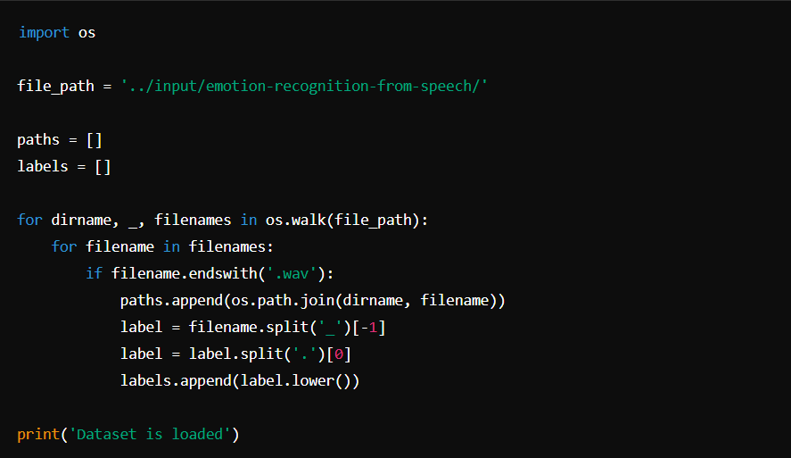

**3.Exploratory Data Analysis (EDA)**

**3.1. Data Overview**

A DataFrame is created to store the paths and labels of the speech files.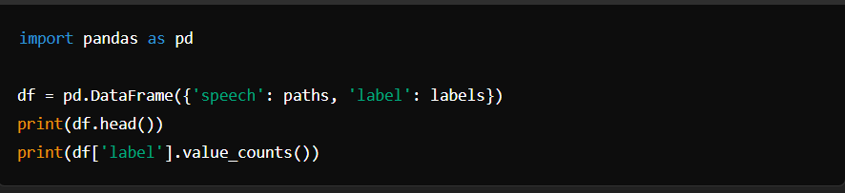

**3.2. Visualization**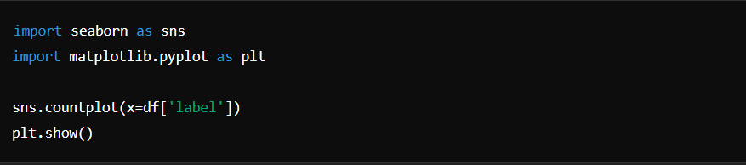

**3.3. Audio Visualization**

Waveforms and spectrograms of example audio files are plotted to understand the characteristics of the data.

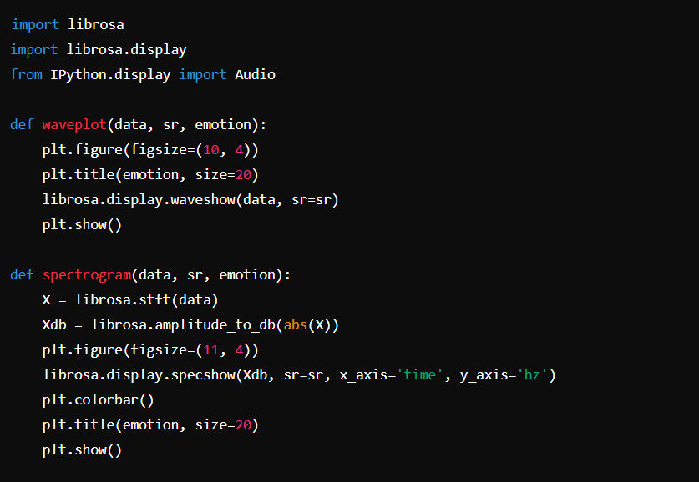

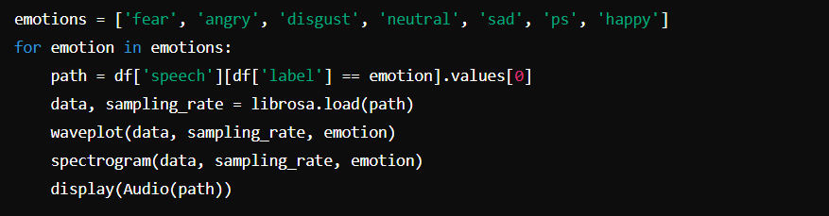

**4. Feature Extraction**

MFCC (Mel-frequency cepstral coefficients) are extracted from each audio file as features.

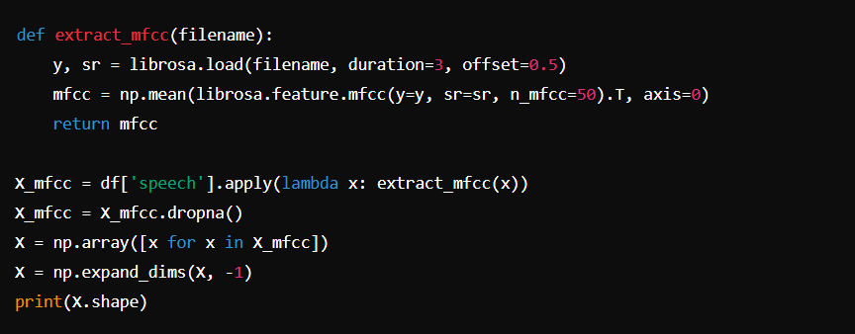

**5. Model Development**

**5.1. Data Preparation**

Labels are one-hot encoded, and the data is split into training and testing sets.

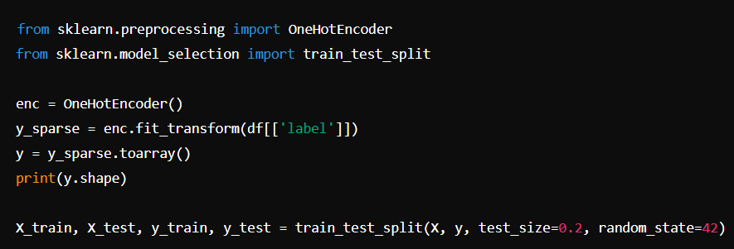

**5.2. Model Definition**

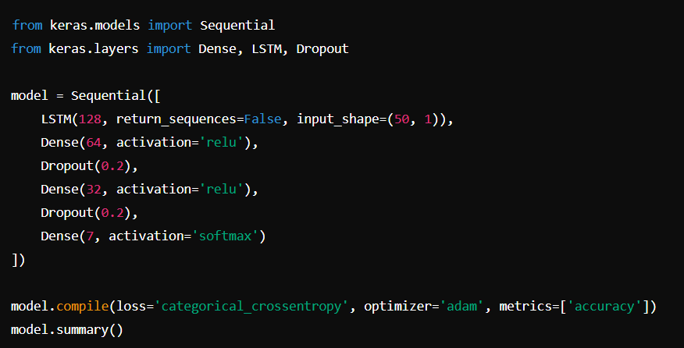An LSTM model is defined to learn temporal dependencies in the audio data.

**5.3. Model Training**

The model is trained using the training data.

***history = model.fit(X_train, y_train, validation_split=0.2, epochs=100, batch_size=512, shuffle=True)***

**5.4. Plotting Results**

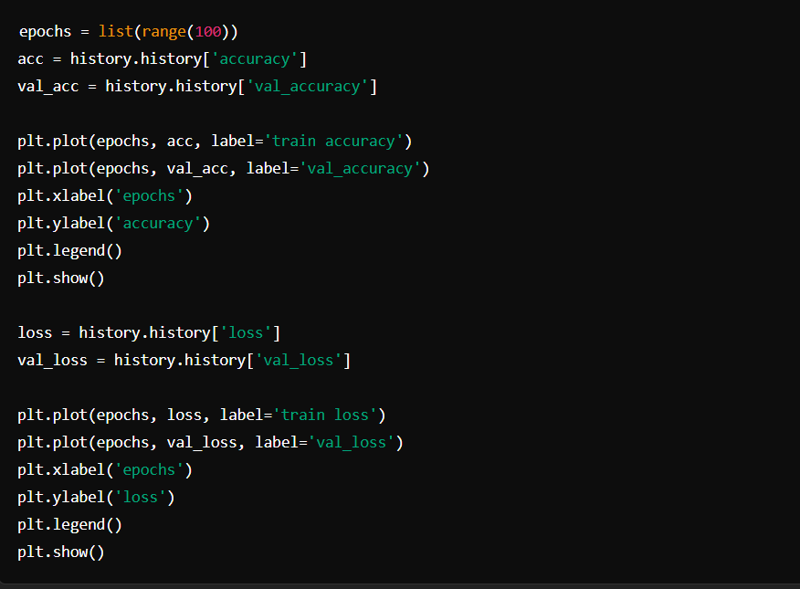The training and validation accuracy and loss are plotted to evaluate the model's performance.

**6.Conclusion**

In this project, I developed a model to recognize emotions from speech using LSTM neural networks. The model was trained on the TESS dataset, and its performance was evaluated using training and validation accuracy and loss. Future work could involve hyperparameter tuning and testing the model on different datasets to improve its robustness.